

DCT DevOps Project Creation

10th Magnitude, LLC
20 North Wacker Drive #530
Chicago, IL 60606

Notice of Confidentiality © 2018 10th Magnitude, LLC All rights reserved

THIS DOCUMENT IS 10TH MAGNITUDE PROPRIETARY AND CONFIDENTIAL INFORMATION AND IS SUBJECT TO THE TERMS OF THE 10TH MAGNITUDE NON-DISCLOSURE AGREEMENT. NEITHER THIS DOCUMENT NOR ITS CONTENTS MAY BE REVEALED OR DISCLOSED TO UNAUTHORIZED PERSONS OR SENT OUTSIDE THE AFOREMENTIONED COMPANY WITHOUT PRIOR PERMISSION FROM 10TH MAGNITUDE.
Table of Contents
Summary 3
Organization Setup 3
Project Setup 5
Project Customization 7
Create a Dashboard 7
Create a Repo 10
Updating the Backlog Templates 10
Adding a Migration Workload Backlog 11

Summary

This document outlines the standard process for creating a DCT customer engagement project in Azure Devops. The backlog creation is automated and based on a predefined backlog template.

High-level Workflow

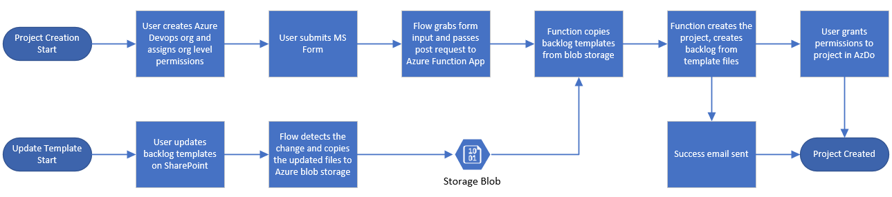

Organization Setup

Each new customer project should have a new organization setup outside of 10Ms internal org. This completely separates the DevOps instance so that it can be easily shared with the customer and eventually be handed over to the customer if desired. To setup a new organization and assign the proper permissions for management of projects within, follow these steps.

- Create a new organization for the customer with the following naming convention.
  - Client-<CustomerName>, for example Client-FootLocker
- Assign permissions to the team owners in the new org.
  - Click Organization Settings in the bottom left corner

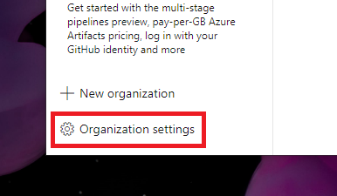

  - Select Permissions, then double-click the Project Collection Administrators group.

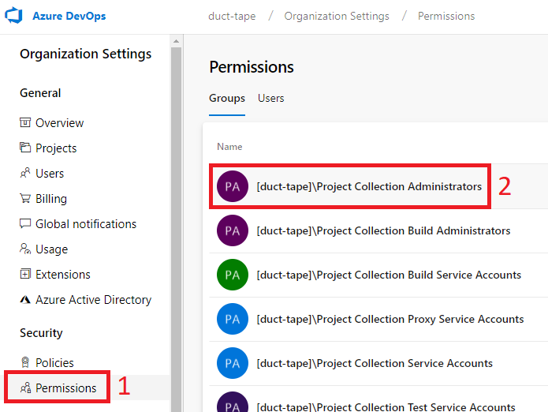

  - Click the members tab, then click the + Add Members button in the top right.

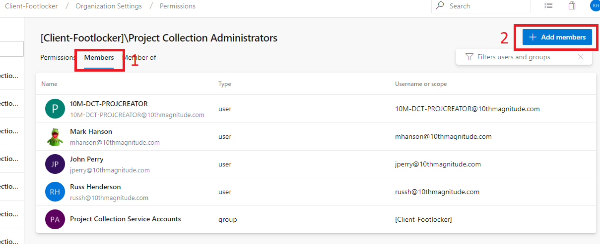

  - Add the 10M-DCT-AzDOAdmins group. This group should contain the service account that will be used to create the project and backlogs, as well as any additional administrative users at the org level.

Project Setup

Each engagement that has a separate SoW should most likely have its own project within the customer org. This allows us to keep current engagements separate from past engagements while allowing us to reference if needed, as well as allowing us to assign separate teams to separate engagements. To setup a new project with automated backlog creation, follow these steps.

- Kick off the functions app that creates the project, teams, and backlogs by filling out and submitting the following form with the necessary info.
  - https://forms.office.com/Pages/ResponsePage.aspx?id=Z7RgZtOtnk2K2kixchlZ859fz2yLLNxNsqKqQ_SvRVJUNURXSzM3VjJFMEhDQ1RSOTRYUUVFUFBSNS4u
- After the project creation has completed, you’ll need to set up the project permissions.
- Add the project teams to the Project Contributors group by clicking Project Settings in the bottom left corner > Security > Contributors > Members Tab > Add.

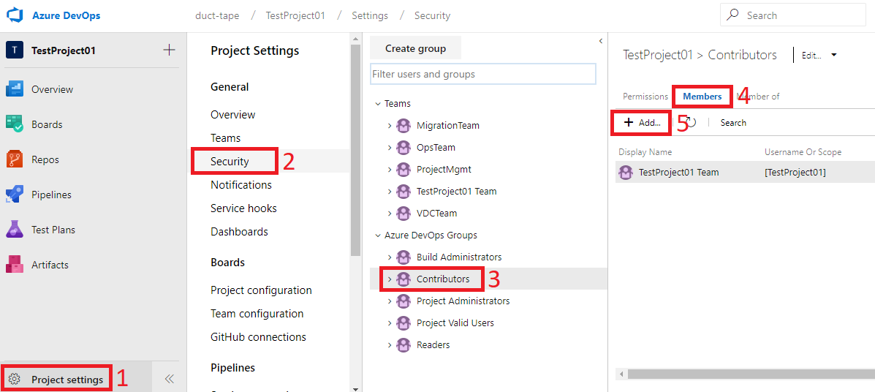

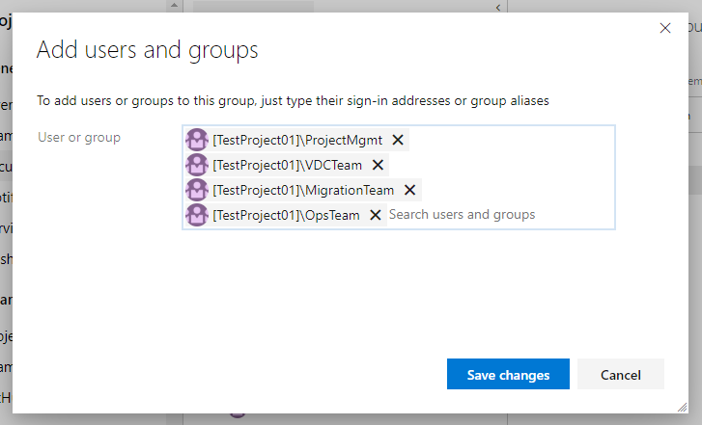

- Add the resources assigned to the project as members of the proper team by going to Project Settings, Teams, clicking the team, then clicking Add.

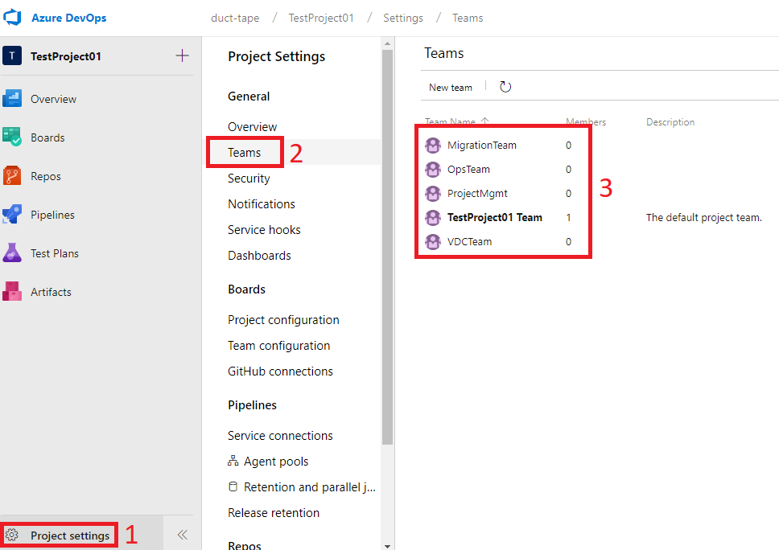

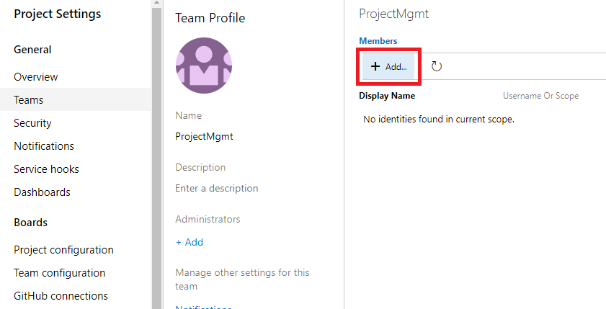

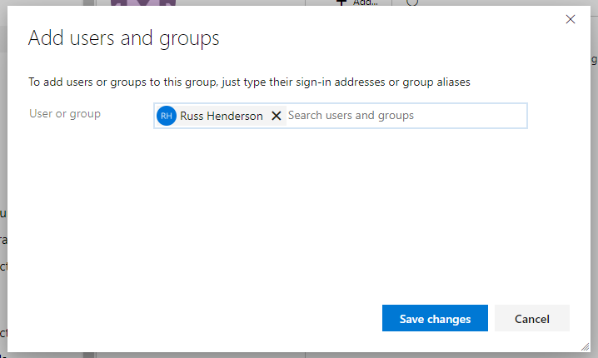

Project Customization

It’s a good idea to customize the project a bit to make sure the timelines fit the SoW and work is visible.

Create a Dashboard
You can setup a simple burndown dashboard by following these steps.

- A good start to a project dashboard would be the following widgets:
  - Markdown widget with the project customer and name, example:

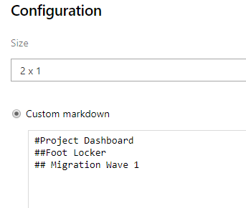

  - Burndown widget - add the teams and sprints here to track overall burndown. Here are some example configs:

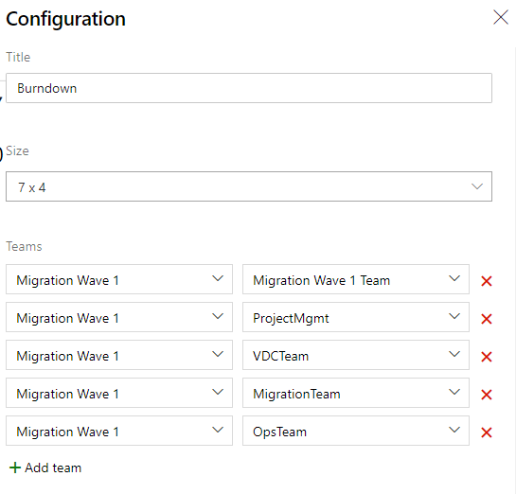 | 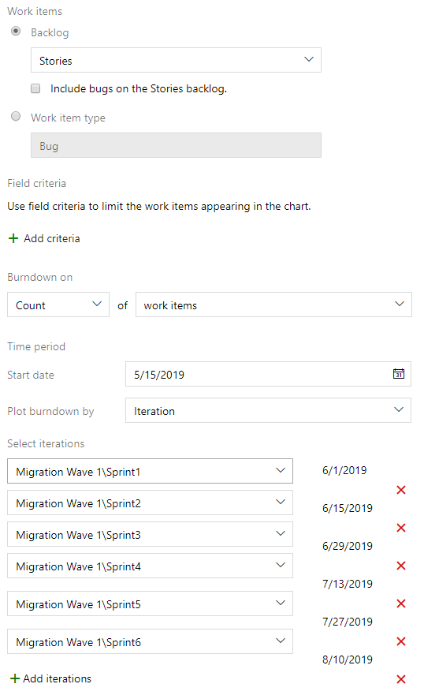

  - Current Sprint Burndown – no configuration needed for this widget.
  - Sprint overviews for each team (or relevant teams at the time).
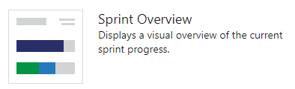

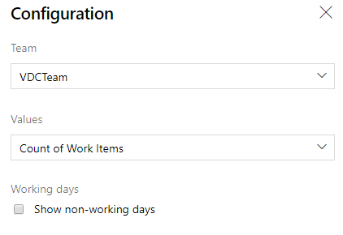

- The finished dashboard should look similar to the following.

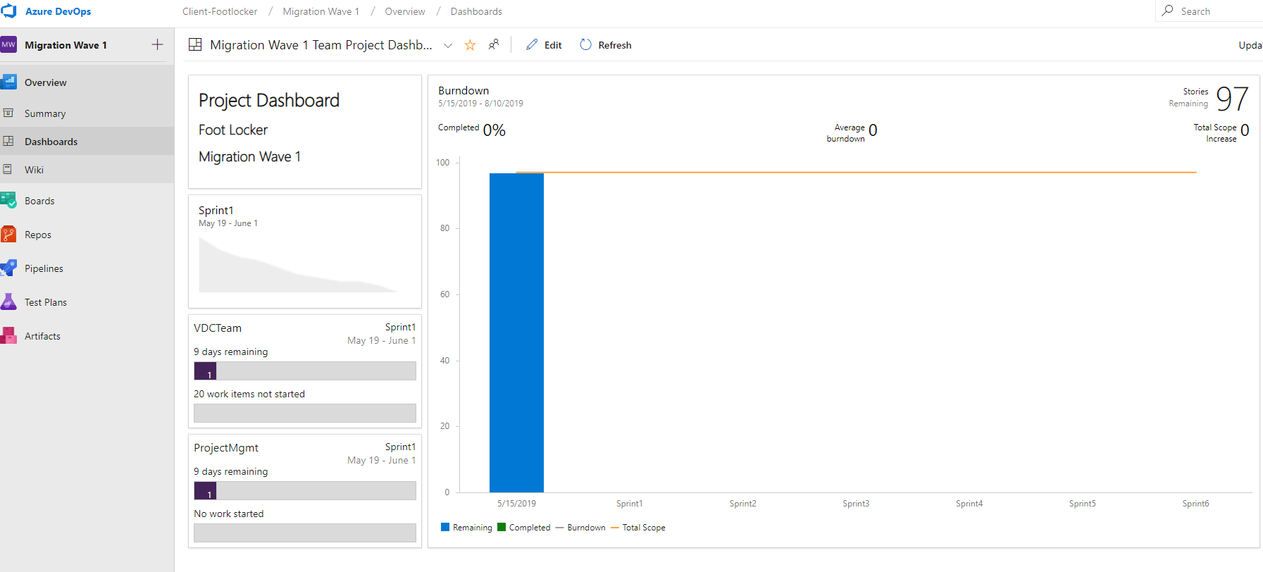

Create a Repo
Create a blank repo for the project to store scripts and templates for the projects that can be used In builds.
- In the project, click Repos.
- You can start with a blank repo by clicking the Add a README and then clicking the Initialize butto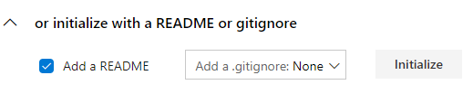

Updating the Backlog Templates
Updates to the backlog templates should be limited to improvements or major changes. You shouldn’t update the backlog template for small customizations for a customer project, etc. Small customizations should be completed on the project after it has been stood up by the automated creation process. Only update the templates if you understand the structure!

To update the template:
- Browse to the Backlog Templates Folder in SharePoint (10M Data Center Transformation Portal\DCT Documents\Project Management\Backlog Templates).
- Open the file in Excel, make your changes, save the file.
- WAIT around 5-10 minutes for the Flow automation to pick up the file change and copy the updated file to the Azure Blob storage used by the Project Creator Function App before creating a new project.

Adding a Migration Workload Backlog
A separate automated process has been created to Import IaaS workloads and associated servers Into DevOps for migration process tracking. The process Is template driven. Based on the template provided, the process will create a story for each workload and a child task of that story for each server In the workload.
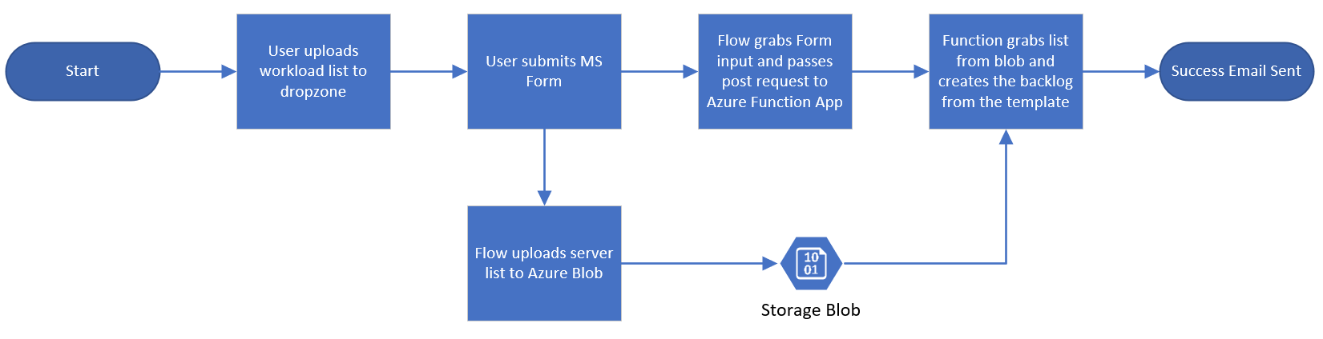
Before you get started, these prerequisites must be met:
- A DevOps project must exist and be configured for a migration
- A workload group feature will need to exist for the workload stories and tasks to be created In. You will need the ID of the feature to provide In the setup form.
To create the backlog:
- Download a copy of the workloadmigration_example.csv file from SharePoint and add your server list. You can also use the workloadmigration_example.csv file to see the proper formatting. Make sure each workload server list Is together, and then followed by the next or you will get duplicate workloads during creation.
- Upload your completed server list to the dropzone on SharePoint. Make sure you keep a copy of your file, It will be removed from this location on a successful Import.
- Fill out the form to kick off the process. You will need the following Information handy:
  - Filename of your CSV server list you uploaded.
  - Name of the DevOps Organization
  - Name of the DevOps Project
  - ID of the workload group feature In which you want the backlog to be created In.
- You'll get an email on successful completion.
This process can be used multiple times, even In the same Feature to add additional workloads.

